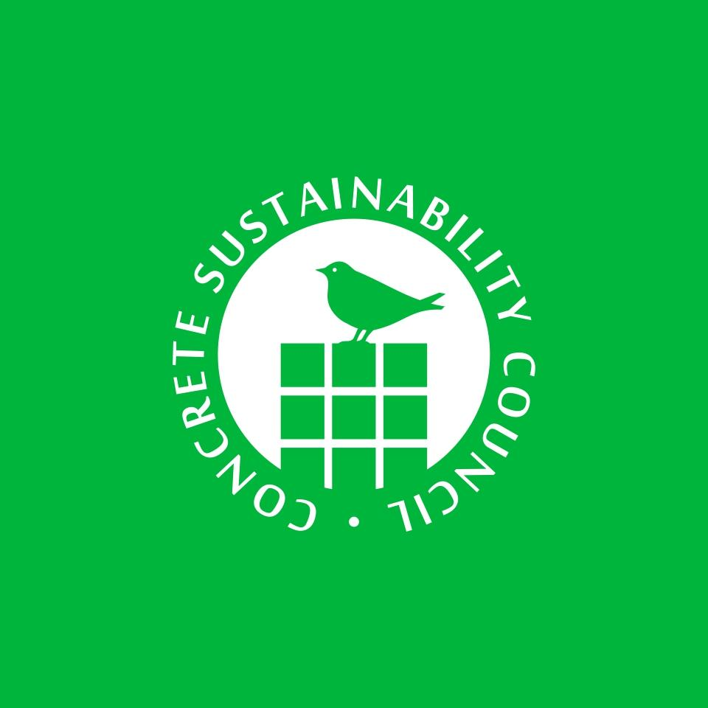

### **Concrete Sustainability Council (CSC) Theory of Change**

### **Introduction**

The Concrete Sustainability Council (CSC) was established after the adoption of the United Nations Sustainable Development Goals (SDGs) in 2015, recognizing concrete’s potential to contribute to resilient, sustainable communities around the world. Concrete is not only the most widely used construction material globally—14 billion m³ produced in 2020—but it is also inherently local, durable, and versatile, making it the material of choice for safe and climate-resilient infrastructure.

The CSC was founded in 2016 under the roof of the World Business Council for Sustainable Development (WBCSD), in collaboration with concrete producers, trade associations, NGOs for the protection of biodiversity, and certification companies. Its mission: to develop and implement a transparent, credible certification system for responsibly sourced concrete and its supply chain. Launched on January 1st, 2017, the CSC Certification System supports the transition to low-carbon, circular, and socially responsible practices in the construction sector.

The CSC also aligns its certification system development and governance with internationally recognized good practices for sustainability standards as promoted by the ISEAL Alliance - International Social and Environmental Accreditation and Labelling Alliance. By engaging with ISEAL’s Codes of Good Practice, CSC reinforces its commitment to credibility, transparency, and continuous improvement—placing it alongside other leading sustainability standards, such as Forest Stewardship Council (FSC). In the wake of the adoption of the United Nations Sustainable Development Goals (SDGs) in 2015, recognizing concrete’s potential to contribute to resilient, sustainable communities around the world. Concrete is not only the most widely used construction material globally, but it is also inherently local, durable, and versatile, making it the material of choice for safe and climate-resilient infrastructure.

The CSC Theory of Change (ToC) presents a strategic framework for how our certification system and broader initiatives aim to accelerate sustainable practices in the concrete, cement, and aggregates industries. CSC’s approach integrates four interconnected impact pathways, each supported by key enabling strategies.

We are creating a market pull for sustainable concrete by promoting sustainable construction with CSC-certified concrete. As of 2025, there are over 1470 active certificates across 25 countries/regions. The CSC certification system is gaining recognition in leading third-party verified sustainable building and infrastructure labels such as LEED, BREEAM, DGNB, ENVISION, CEDBIK and CASA. Cement, concrete, and aggregates plants can be certified, with criteria covering Management, Environmental, Social, Economic, and Chain of Custody categories.

Our ultimate goal is to decarbonize the construction value chain and ensure that sustainability practices become the norm rather than the exception.

### **Problem Statement**

Despite its sustainability potential, concrete production is a major source of global CO2 emissions, primarily due to the carbon intensity of cement, the key binding material in concrete. Additional environmental pressures stem from resource extraction, water use, and land degradation, while social challenges persist around labor standards and community engagement.

However, concrete also offers substantial benefits. Among others it absorbs CO2 through carbonation, can be produced with recycled aggregates, has high thermal mass, and contributes to disaster-resilient and durable infrastructure. To unlock this potential, a comprehensive certification system is needed—one that fosters transparency, aligns the industry with the SDGs, and transforms sustainable production from exception to norm.

### **FSC and ASI-Inspired Impact Framework**

CSC's Theory of Change draws inspiration from both the Aluminium Stewardship Initiative (ASI) and the FSC, aligning with their principles of transparency, inclusiveness, and performance-driven sustainability. Like FSC, CSC recognizes that certification systems must drive change not only through compliance but by creating incentives for continual improvement across environmental, social, and governance dimensions. From ASI, CSC adopts a structured, time-bound impact logic and modular certification model that enables scalability and sector-wide transformation. These are structured as follows:

#### 

#### 

#### **Long-Term Impact**

Concrete becomes the default sustainable, low-carbon, circular, and resilient construction material globally—making a meaningful contribution to climate goals, biodiversity protection, and the achievement of the SDGs.

#### **Medium-Term Outcomes**

* Construction projects increasingly specify CSC-certified concrete materials.
* CSC modules (e.g. R-Module, CO₂-Module) are widely adopted to enhance transparency and sustainability performance.
* CSC certification is formally integrated into green building standards, green public procurement (GPP) frameworks, and investment requirements.

#### **Short-Term Outcomes**

* Producers seek CSC certification and meet bronze, silver, gold, or platinum levels.
* CSC becomes a recognized label in public procurement.
* Stakeholders report improved transparency, credibility, and comparability of sustainability data.

#### **Preconditions and Assumptions**

* There is demand for sustainable, responsibly sourced materials.
* Public policy and investor frameworks favor certification.
* Certification bodies maintain high-quality, credible assurance mechanisms.
* Industry capacity exists to implement changes required by the CSC system.

These principles underpin CSC’s four interconnected pathways (Engagement, Standards, Assurance, Market) and reinforce its alignment with ISEAL Alliance guidance for credible sustainability systems.

### **Vision**

A global construction sector where concrete is produced and used in ways that are environmentally responsible, socially beneficial, and economically viable—fully aligned with climate goals, circular economy principles, and the UN Sustainable Development Goals (SDGs).

### **CSC’s Four Impact Pathways**

#### **1. Engagement Pathway: Building Consensus and Trust**

CSC convenes industry actors, certification bodies, buyers, NGOs, and public authorities through participatory processes to co-create sustainability solutions. This pathway emphasizes:

* Transparent stakeholder dialogue
* Inclusive governance and regional consultation
* Knowledge-sharing across sectors and regions
* Exchanging with stakeholders to gain external perspective and foster continuous improvement

**Intended effect**: Greater alignment on sustainability expectations, increased legitimacy, and broad uptake of certification.

#### **2. Standards Pathway: Defining Responsible Practices**

CSC’s certification system sets credible, science-based standards for responsible sourcing and production in concrete, cement, and aggregates. It rewards progressive practices such as:

* Fair business practices and compliance
* Reducing CO2 emissions
* Enhancing biodiversity
* Occupational health & safety excellence
* Circularity through the use of returned concrete, secondary materials, and water
* Responsibility in the supply chain

**Key activities**:

* Development and continuous improvement of the CSC Certification System
* Launch of specialized modules, e.g., the R-Module (for recycling and reuse) and the CO2-Module
* Alignment with international frameworks (ISO, ISEAL, UN SDGs)

**Intended effect**: Producers adopt measurable sustainability practices and demonstrate compliance through certification at levels from Bronze to Platinum.

#### **3. Assurance Pathway: Delivering Credibility through Certification**

CSC ensures transparency and trust through third-party audits, accreditation of certification bodies, and corrective action mechanisms. CSC does not audit producers directly; it qualifies and monitors certification bodies to ensure quality and impartiality.

**Components**:

* Accredited certification bodies (e.g., SGS, TÜV, KIWA)
* Publicly available audit summaries
* Grievance and Complaint Management Process

**Intended effect**: Reliable, consistent certification system that is credible to both industry and stakeholders.

#### **4. Market Pathway: Creating Demand and Incentives**

CSC promotes certified products through partnerships, sustainable building label integration, and alignment with procurement frameworks.

**Key mechanisms**:

* Green public procurement (GPP) integration
* Recognition in sustainable building labels
* Engagement with developers, architects, and investors
* Awareness campaigns to shift perception of concrete as a sustainable material
* Incentivizing sustainability through performance-based certification levels

**Intended effect**: Certified concrete becomes the concrete of choice—perceived as durable, circular, low-carbon, and essential for achieving the SDGs.

### **Supporting Strategies**

* **Advocacy**: Engage governments and institutions to promote recognition of CSC certification in procurement and policy (e.g., EU Taxonomy, national GPP).
* **Capacity Building**: Equip suppliers—especially SMEs—to meet CSC. certification requirements through an easy to access easy to use Toolbox and clear Technical Manuals.
* **Monitoring & Evaluation**: Track adoption rates, stakeholder satisfaction, and sustainability impact.
* **Innovation & Learning**: Support use of supplementary cementitious and secondary materials; continuously adapt criteria to reflect technological advances notably for the reduction of CO2 emissions. (Future SMART Goals can relate to the impact of CSC CO2 and R modules. Further discussions with stakeholders are ongoing to include the outcome in an updated version of the ToC.)

### 

### **Certification Levels and Incentives**

CSC certification operates across four progressive levels: **Bronze**, **Silver**, **Gold**, and **Platinum**. These levels serve as a performance ladder that encourages continuous improvement. Each level requires increasing compliance with sustainability criteria across management, environmental, social, and economic categories.

| **Level** | **Description** | **Key Incentives & Requirements** |
| --- | --- | --- |
| Bronze | Entry-level certification meeting core prerequisites | Demonstrates basic commitment to responsible sourcing and compliance |
| Silver | Intermediate level with mandatory criteria in key sustainability areas | Eligible for CSC add-ons (R-Module and CO₂-Module); strengthens position in GPP and tenders, recognized across major sustainable building standards (e.g, LEED, BREEAM, DGNB) |
| Gold | High-performance certification reflecting broad sustainability integration | The company has many supporting policies, such as purchasing policies, Environmental Product Declarations, and externally verified KPIs published |
| Platinum | Leadership level showcasing industry best practices and innovation | Positions producers as frontrunners in circularity, decarbonization, and social responsibility |

These performance levels serve as **strategic incentives**, rewarding companies that align with global ESG goals and increasing their visibility in procurement, real estate, and investment markets.

### **Intended Impacts**

| **Area** | **Impact** | **Examples of Indicators** |
| --- | --- | --- |
| Environmental | Reduction in GHG emissions, water, and raw material use, biodiversity protection | % CO2 reduction, % use of secondary materials, # of CO2-Module certifications |
| Social | Improved worker safety, equity, and social responsibility | Compliance with social criteria, health & safety metrics, stakeholder feedback |
| Economic | Responsible sourcing becomes the norm | # of certified plants, # of public projects using CSC-certified materials |

### **Assumptions**

* Concrete’s sustainability performance can shift through education, innovation, and transparency.
* Public and private procurement will increasingly prioritize sustainability.
* Certification and labeling influence market behavior when backed by credible systems.
* Collaboration with organizations like GCCA, Global ABC and sustainable labels accelerates sector transformation.

### **Risks and Mitigation**

| **Risk** | **Mitigation Strategy** |
| --- | --- |
| Low awareness of certification value | Awareness campaigns and targeted stakeholder outreach |
| Fragmentation in certification uptake | Harmonization with sustainable building labels and GPP tools |
| Perceived cost of certification | Highlight business case, incentives, and financing links |

### **Additional Considerations**

CSC certification significantly improves the sustainability performance of concrete and provides a platform for responsible producers to distinguish themselves in the market. Its modular approach—including the R-Module for recycled aggregates and the CO₂-Module for carbon reductions—adds transparency and fosters continuous improvement.

As more countries adopt Green Public Procurement frameworks and integrate sustainability into legislation and real estate investment decisions, CSC is strategically positioned to support this transition. The certification is already recognized by major third-party verified sustainable building and infrastructure labels such as BREEAM, DGNB, LEED, ENVISION, CASA and ÇEDBİK, and enables companies to meet growing expectations for ESG performance.

By 2025, 1,470 concrete, cement, and aggregate plants have achieved CSC certification across 25 countries. This success underscores the sector’s momentum—and the critical role of credible, independent certification in driving transformation.

### **Conclusion**

The CSC Theory of Change provides a roadmap to a more sustainable, low-carbon concrete industry. By combining credible standards, independent certification, multi-stakeholder collaboration, and market-driven incentives, CSC enables systemic change in one of the world’s most critical sectors.

Looking forward, CSC will continue raising awareness, creating incentives, and engaging with governments, investors, and industry leaders to ensure responsible sourcing and sustainability are not just recognized—but expected.

This Theory of Change is a living document and will be reviewed regularly to ensure its relevance and effectiveness

